Computer Vision Assignment A1

# Question 1

$$P= \left({4 \atop \begin{aligned}-2 \\ 0\end{aligned}}\right)+t\left({0 \atop \begin{aligned}1 \\ 2\end{aligned}}\right)= \left({4 \atop \begin{aligned}-2+t \\ 2t\end{aligned}}\right)$$

$$The projection will fall on the 2D image plane at \left(a,b,c\right)$$

$$∴$$

$$c=2t=f^{'}$$

$$t=\frac{f'}{2}$$

$$b= -2+t$$

$$b= -2+ \frac{f^{'}}{2}$$

$$a=4$$

$$∴ \left(a,b,c\right)= P^{'}=(4,-2+\frac{f^{'}}{2},f')$$

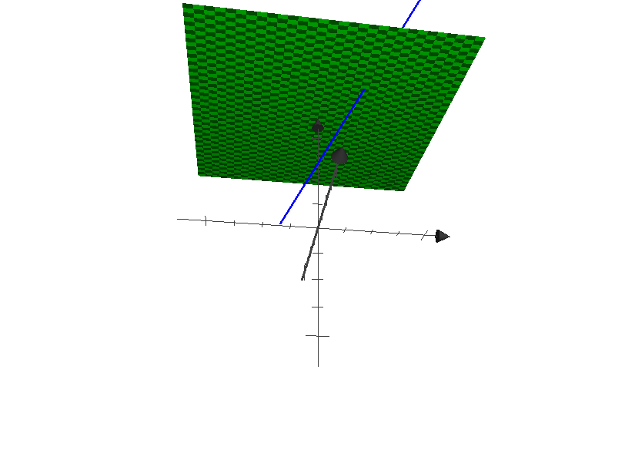

Figure Example projection when f' = 4

# Question 2

## Part 1

Use the Gaussian Lens Formula

$$\frac{1}{i}+\frac{1}{o}=\frac{1}{f}$$

Use the image magnification formula

$$\frac{h_{i}}{h_{o}}=-\frac{d_{i}}{d_{o}}=m$$

The lens must be placed a distance of $d_{o}$ away from the object and the relationship between $do and di$ is given by the following equation:

$$w=d_{o}+d_{i}=1.1m$$

Given that the projected image is half the size of the original object, we can solve for both $d_{o}$ and $d_{i}$.

$$m=\frac{h_{i}}{h_{o}}=\frac{1}{2}=-\frac{d_{i}}{d_{o}}$$

$$∴$$

$$d_{o}=-2d_{i}$$

$$Using the relationship between d_{o} and d_{i}: 2d_{i}=1.1-d_{i}$$

$$d_{i}=\frac{1.1}{3} → d_{o}=\frac{2.2}{3}$$

## Part 2

Use the Gaussian Lens Formula and the values derived above…

$$\frac{1}{d_{i}}+\frac{1}{d_{o}}=\frac{1}{f}$$

$$f= \frac{3}{1.1}+\frac{3}{2.2}=\frac{45}{11}$$

## Part 3

Solve the Blur Circle Diameter Equation, plugging in actual values for x and d.

$$r= \frac{A}{2i^{'}}\left(i^{'}- i\right), where \left(i^{'}-i\right)= \frac{f}{(o^{'}-f)}+\frac{f}{(o-f)} (o-o^{'})$$

Where:

$$A=d$$

$$o^{'}=d_{o}+x$$

$$o=d_{o}$$

$$f=\frac{45}{11}$$

# Question 3



The 5X5 image is displayed as follows.

image = [  
 [ 0, 135, 0, 135, 0],  
 [0, 0, 0, 0, 0],  
 [180, 180, 180, 0, 135],  
 [180, 180, 180, 0, 0],  
 [180, 180, 180, 0, 135]  
 ]

## Part 1: Local Averaging Filter



Figure Original image



Figure : Padded

To average the image we applied this filter.

**Filter** =

[[ 0.1 0.1 0.1]

[ 0.1 0.1 0.1]

Figure : Averaged image

[ 0.1 0.1 0.1]]

**Resultant Imag**e =

[ 13 13 27 13 13]

[ 49 67 63 45 27]

[ 72 108 72 49 13]

[108 162 108 81 27]

[ 72 108 72 49 13]

## Part 2: Median Filter

**Filtered Image** =

[ 0 0 0 0 0]

[ 0 0 0 0 0]

[180 180 0 0 0]

[180 180 180 135 0]

[180 180 180 135 0]]



Figure : Median filtered image

# Question 4

For the following question, I used this image.

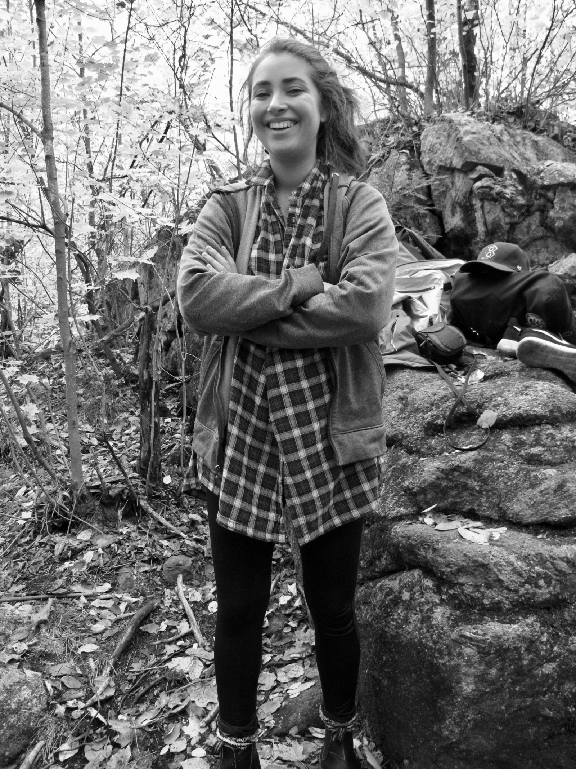

Figure The original image

## Part 1

Convolution function with the following kernel :

[[-0.1 -0.1 -0.1 ]

[-0.1 0.80000001 -0.1 ]

[-0.1 -0.1 -0.1 ]]

Produced the following image

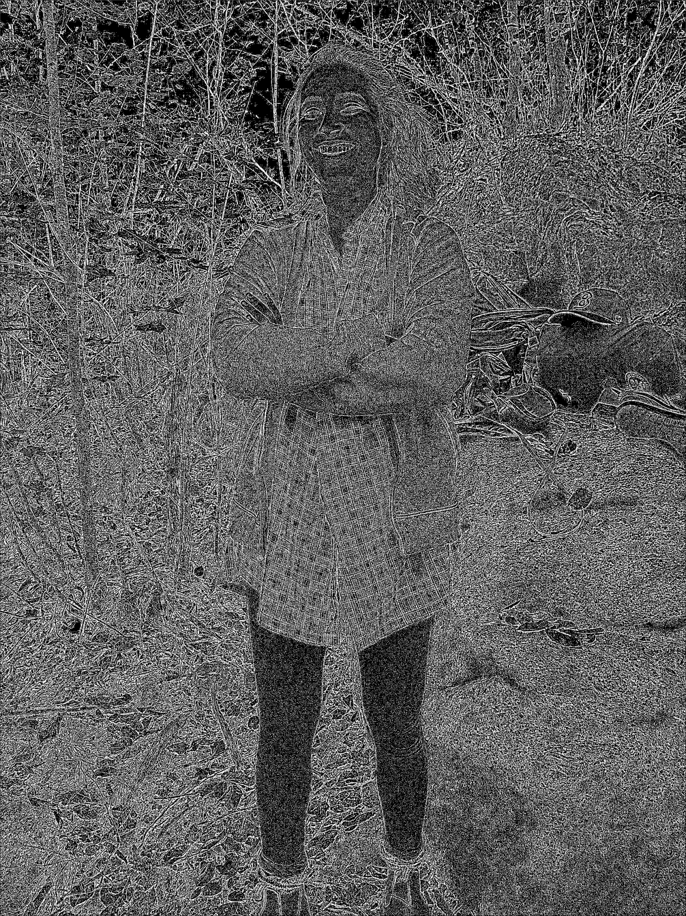

Figure Convoluted image with specified kernel

## Part 2

Sobel filter with colorization.

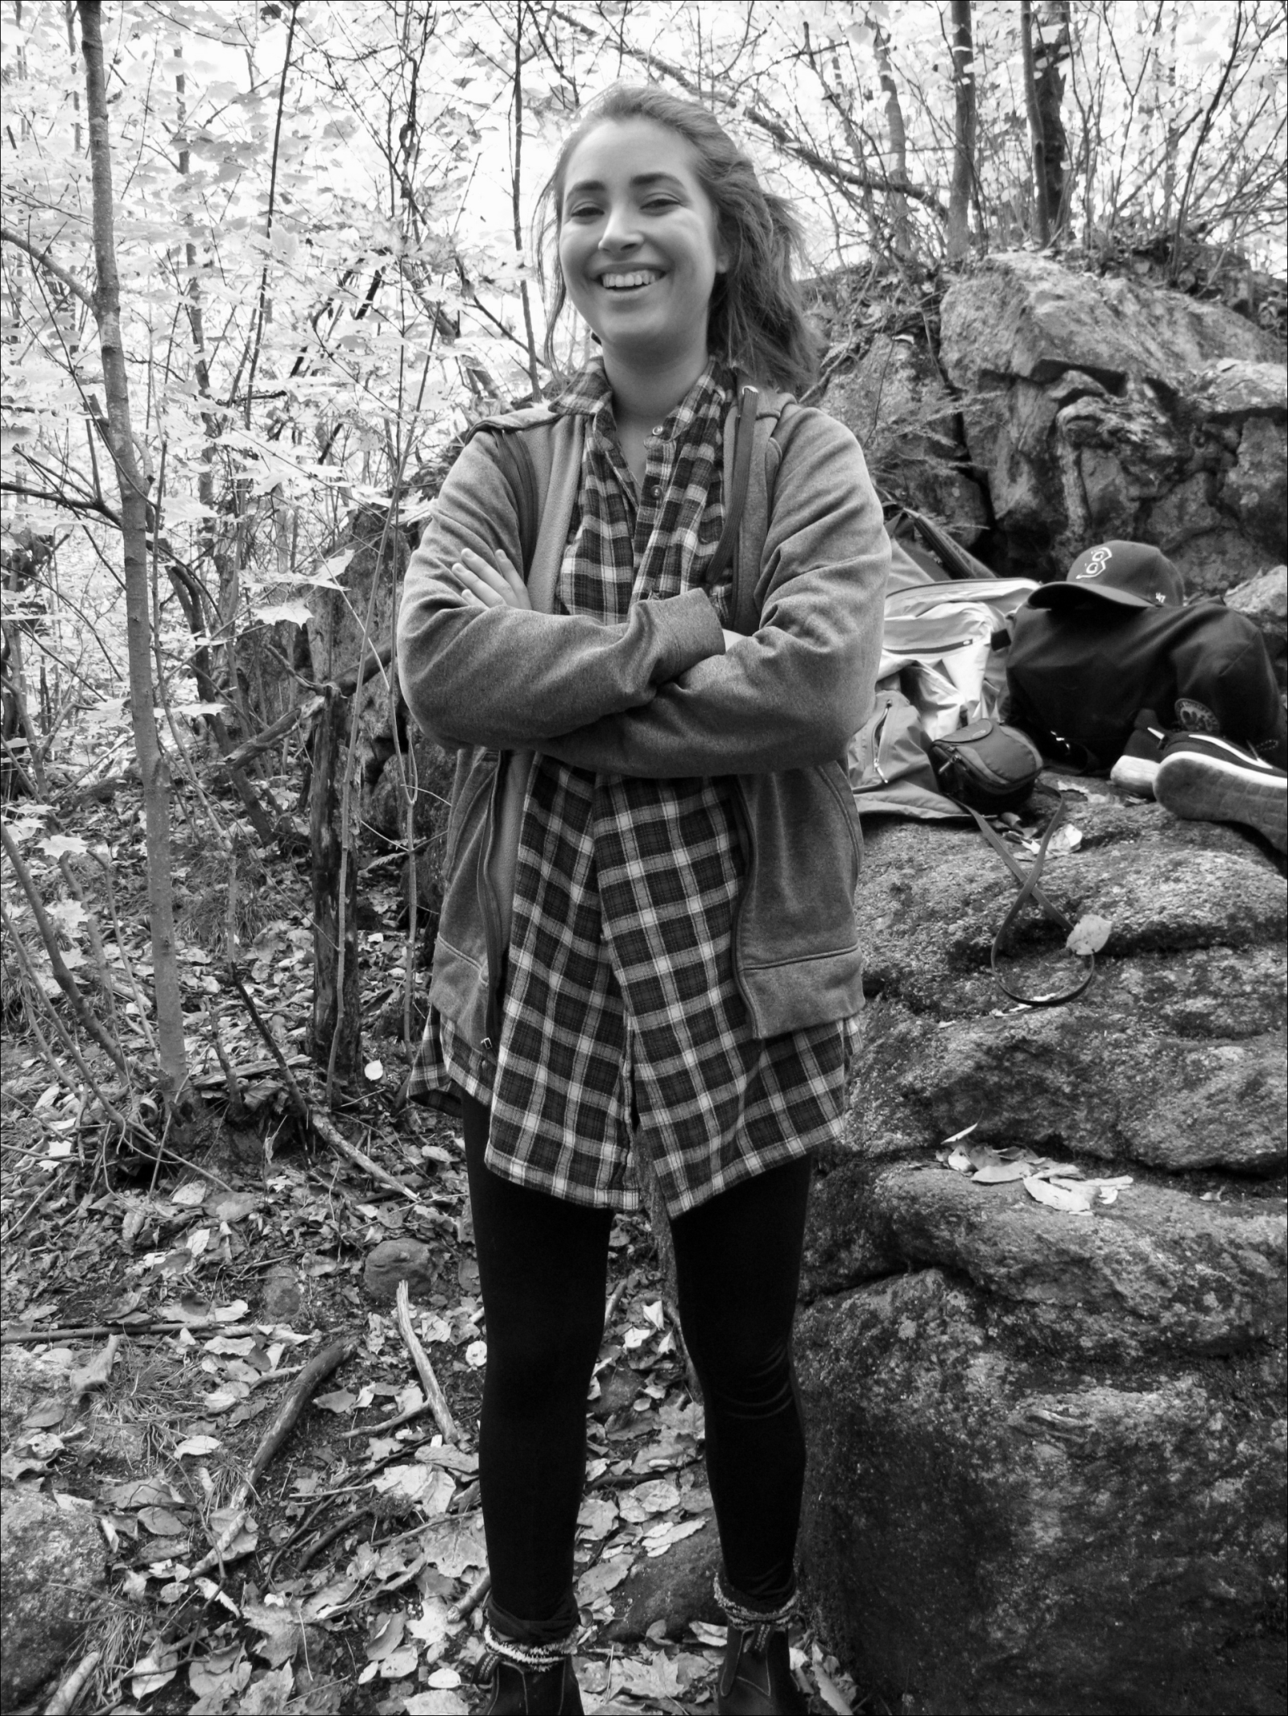

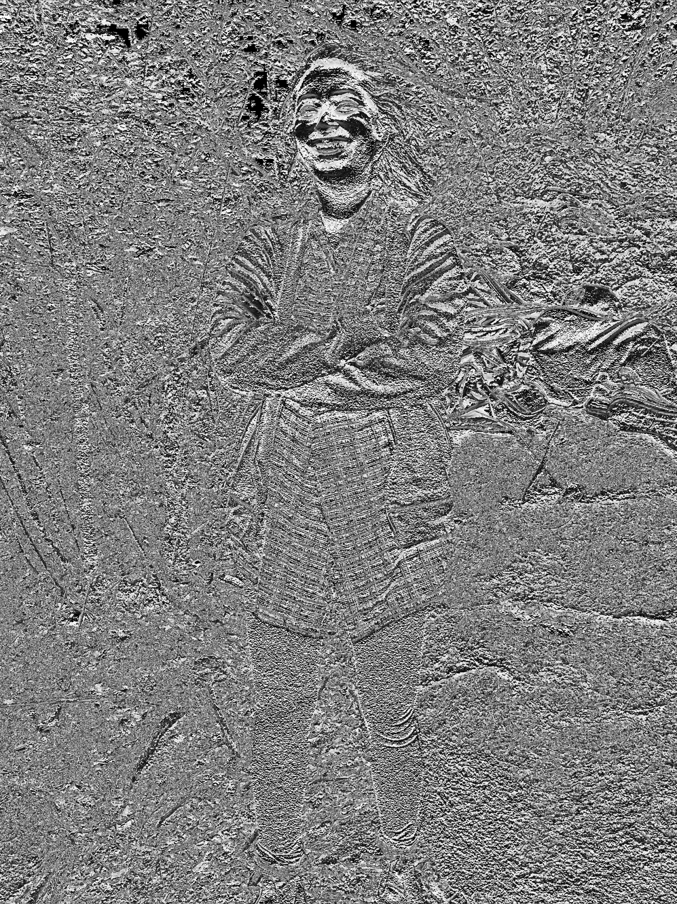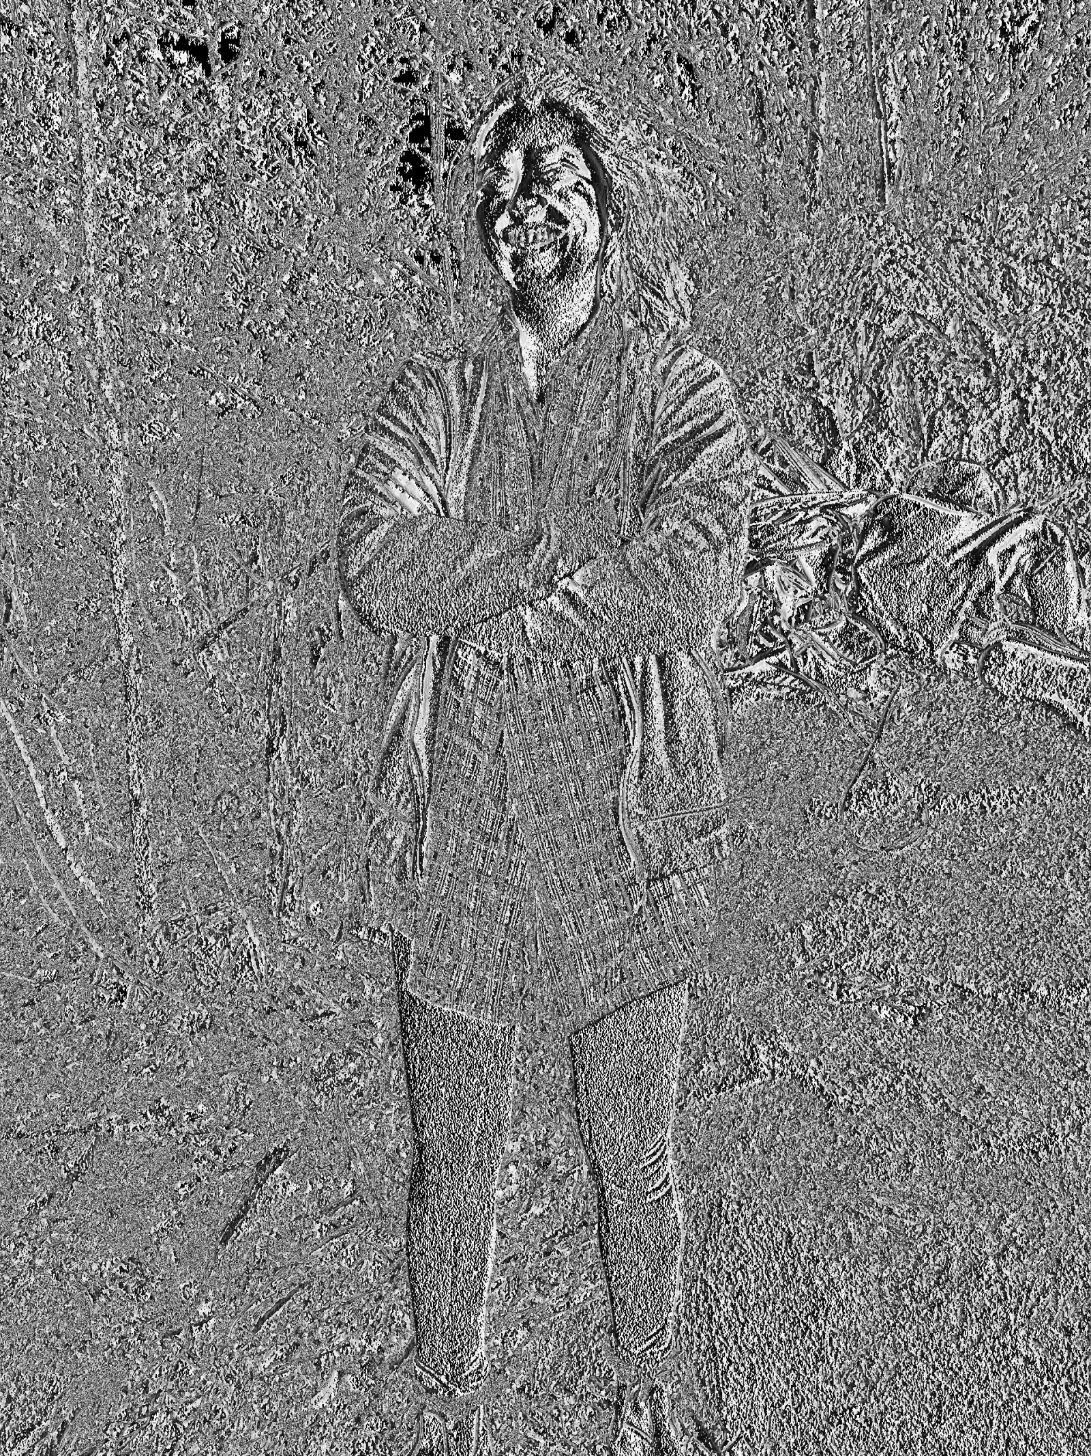Figure Padded image with 0 border

Figure Y Sobel Filtered Image

Figure X Sobel Filtered Image

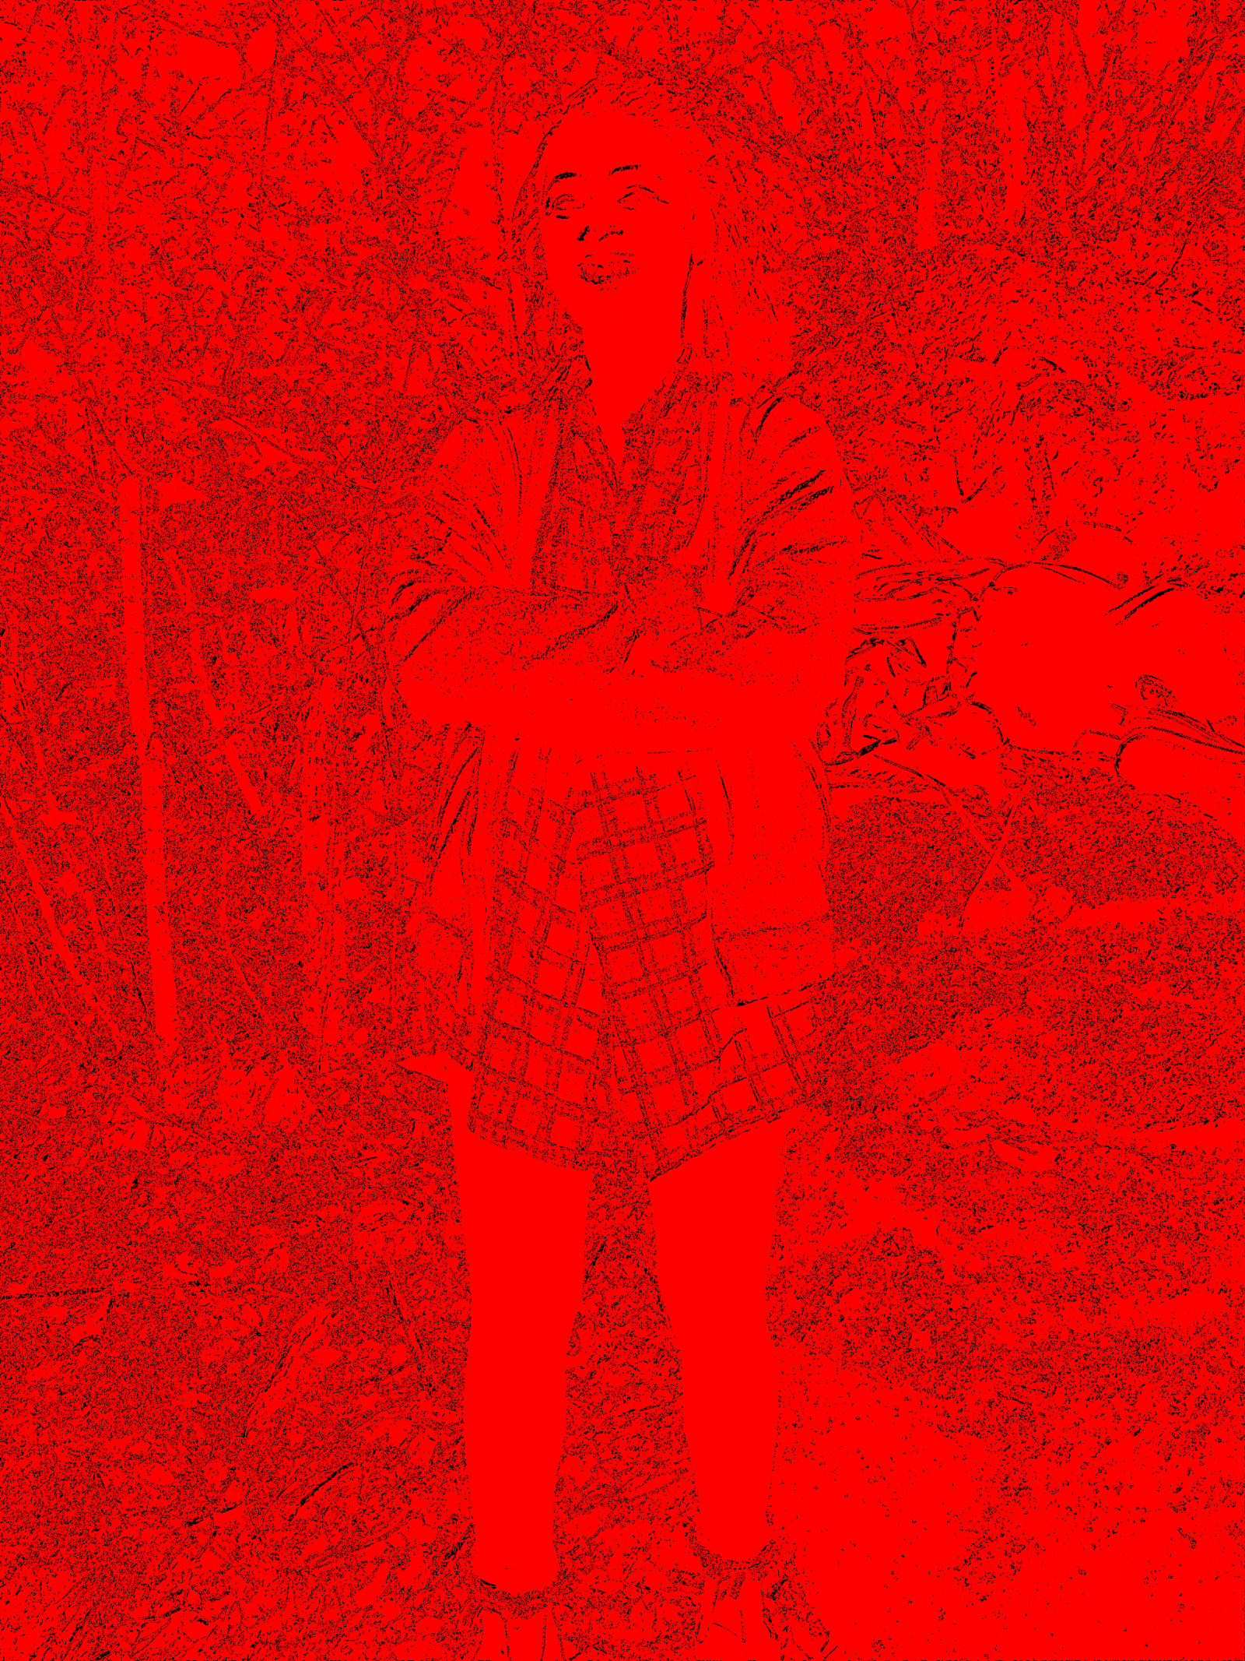

Figure Sobel Colorized image

## Part 3

Histogram, binary threshold image.

**Greyscale Histogram**

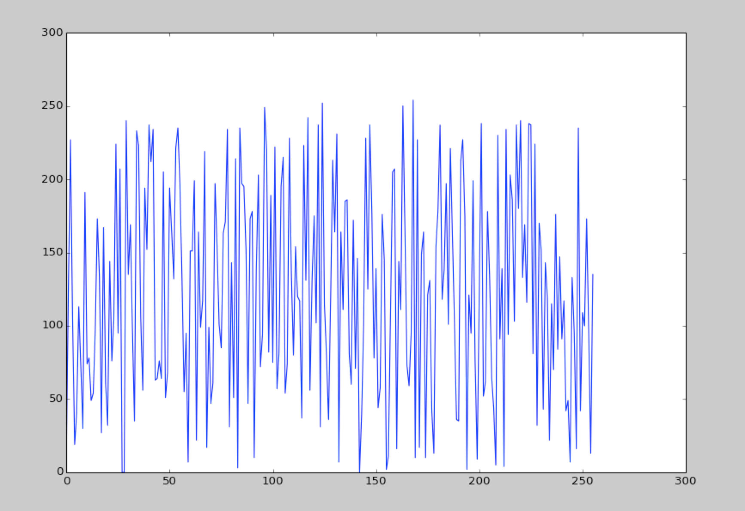

**Color Histogram**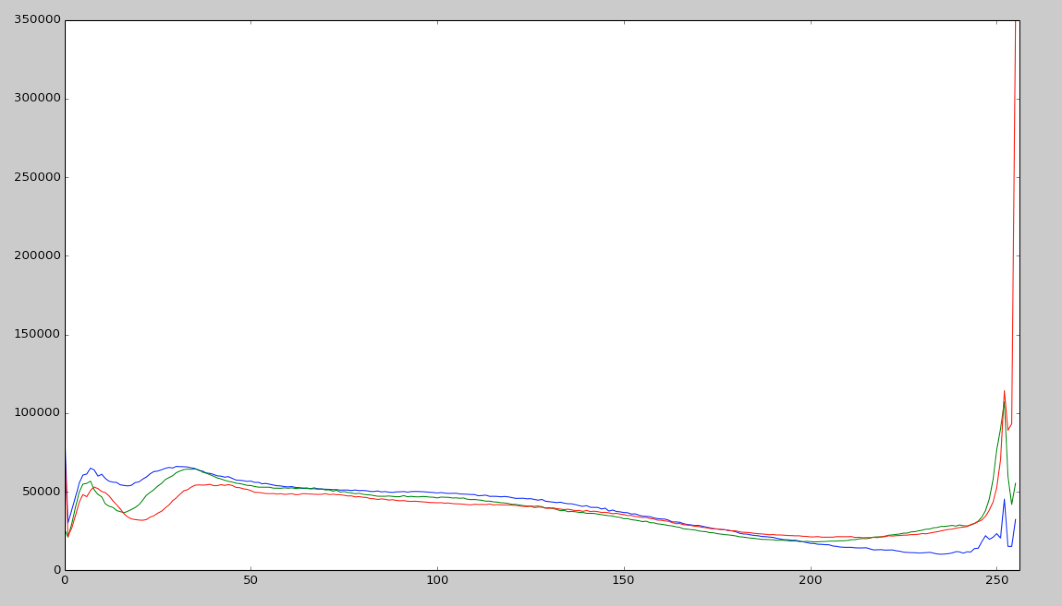

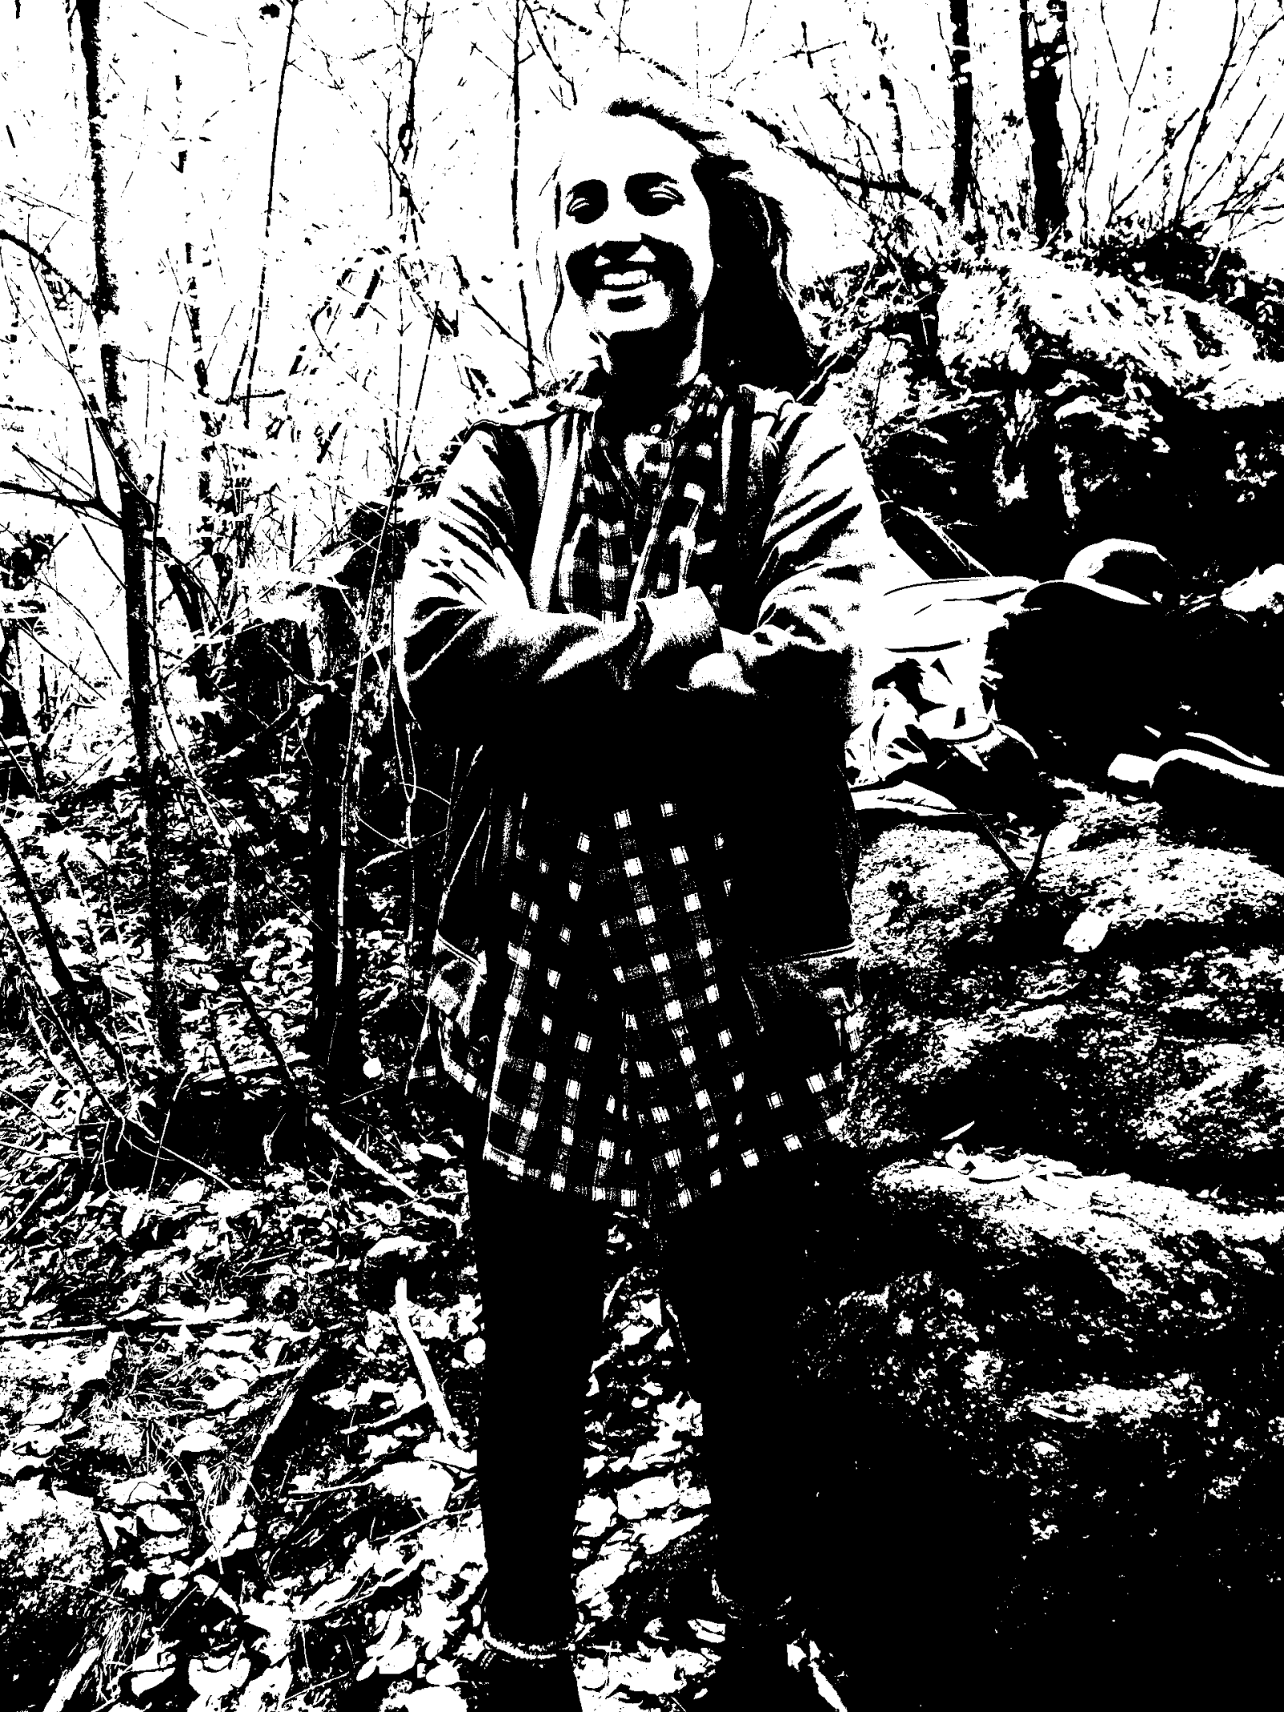

Figure Binary Image